Service Now Project Documentation

# Introduction

➢ **Project Title:** Educational Organisation Using ServiceNow➢ **Team Members:**

**Team ID :** NM2025TMID09021

**Team Size :** 4

**Team Leader :** R T SHAMA PRASAD

**Team member :** M SENTHIL

**Team member :** L MOSES

**Team member :** M A NISHANTH

# Project Overview

➢ **Purpose:** To develop a robust Educational Management System using ServiceNow to manage admissions, student progress, and institutional data with automated workflows and form configurations.➢ **Features:**

* Online admission form with approval workflow
* Student and teacher data management
* Academic progress tracking dashboard
* Notifications for task status and approvals
* Role-based access control for admins, teachers, and students

# Architecture

* **Frontend:** 
  + Developed using HTML, CSS, and JavaScript
  + UI built through ServiceNow UI Pages and Catalog Items
* **Backend:** 
  + Business logic implemented via ServiceNow Script Includes, Business Rules, and Flow Designer
* **Database:** 
  + Tables created using the Table module in ServiceNow
  + Data stored in platform-native schema with relationships and references

# Setup Instructions

➢ **Prerequisites:**

o ServiceNow Developer Account o Personal Developer Instance (PDI) o Basic knowledge of ServiceNow Studio ➢ **Installation Steps**:

**Step 1**: Sign in at [https://developer.servicenow.com](https://developer.servicenow.com/)

**Step 2:** Request and activate your Personal Developer Instance

**Step 3:** Create Update Set → Tables → Forms → Process Flows

**Step 4:** Deploy Client Scripts for automation

# Folder Structure (Logical in Studio)

EducationalOrganisation/

├── Tables/

│ ├── x_edu_student

│ ├── x_edu_teacher

│ ├── x_edu_admission

│ └── x_edu_progress

├── UI Pages/

│ ├── admission_form

│ └── student_dashboard

├── Script Includes/

│ └── AdmissionWorkflowUtils

├── Client Scripts/

│ └── validate_form.js

└── Styles/

└── styles.css

# Running the Application

To run the application:

* Login to your ServiceNow PDI
* Navigate to the created application

* Use the left navigation pane to open modules such as:

o Admission Form o Student Records o Progress Dashboard

* Perform form submissions and automation testing

# API Documentation

* GET /api/x_edu_org/students
* Response:
  + {
  + "student_id": "STU102",
  + "name": "A. Chaithanya",
  + "department": "Computer Science"
  + }

# Authentication

• Role-based access is implemented using admin, teacher, and student roles, managed through ServiceNow Access Control Rules (ACLs).

# User Interface

* Designed with HTML, CSS, and JavaScript using ServiceNow UI Pages for a clean and responsive layout.
* Includes dashboards, admission forms, student profiles, and result tracking interfaces.
* Role-based access displays relevant modules for admin, teacher, and student users.

# Testing

* Manual testing was done through the ServiceNow form submission interface.
* Validations verified via onChange and onLoad client scripts.
* Fields were tested for automation, data flow, and visual updates.

# Screenshots or Demo

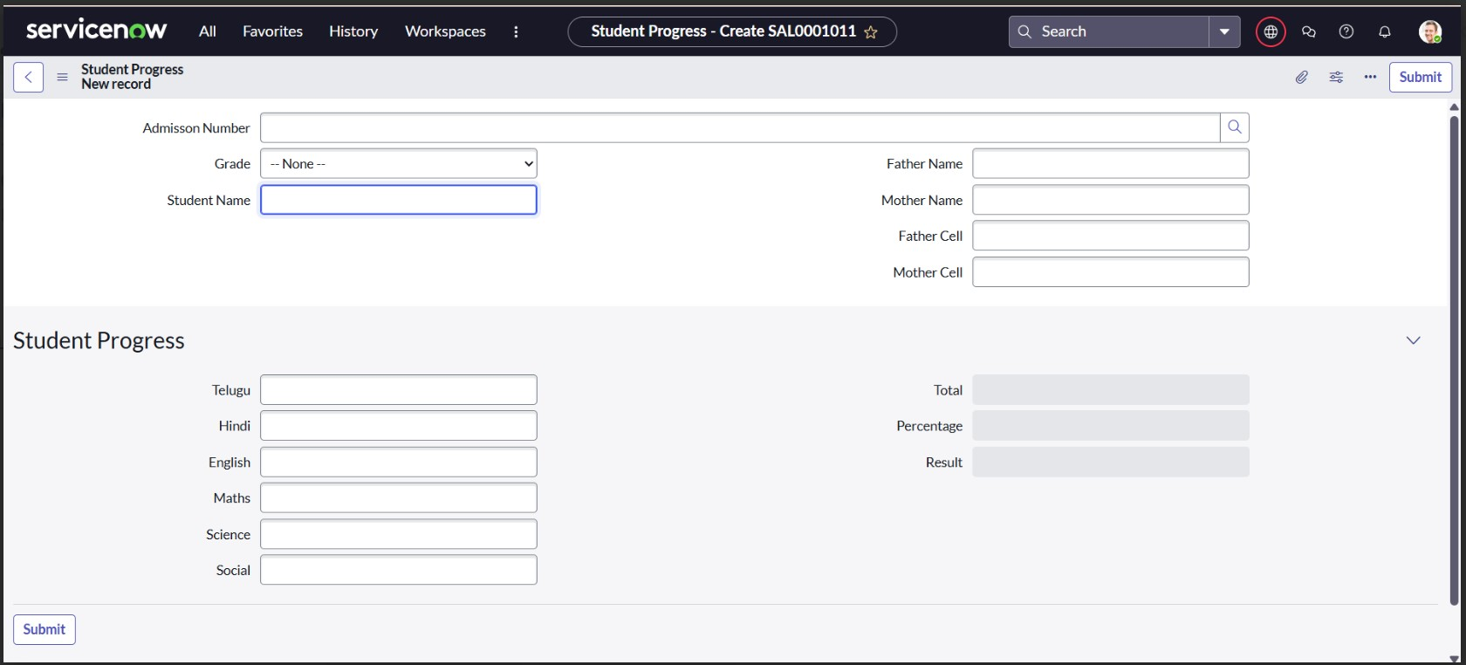

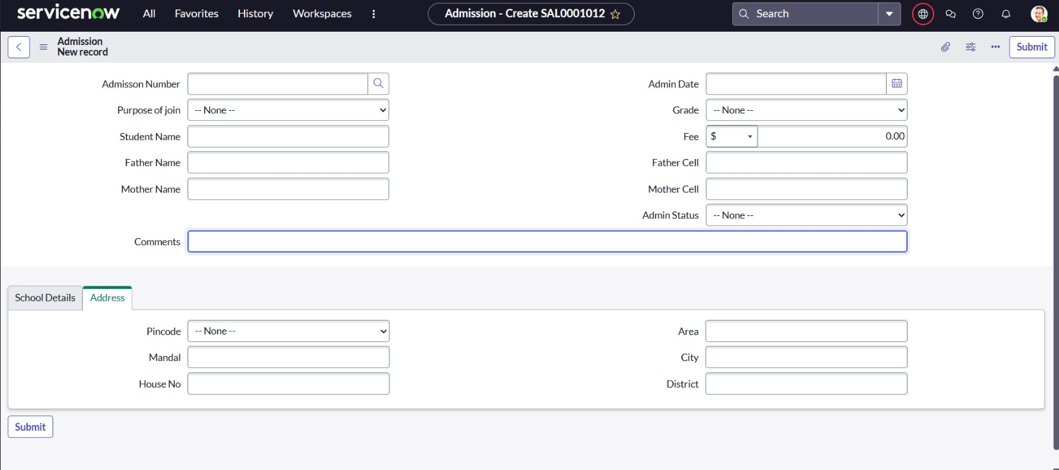

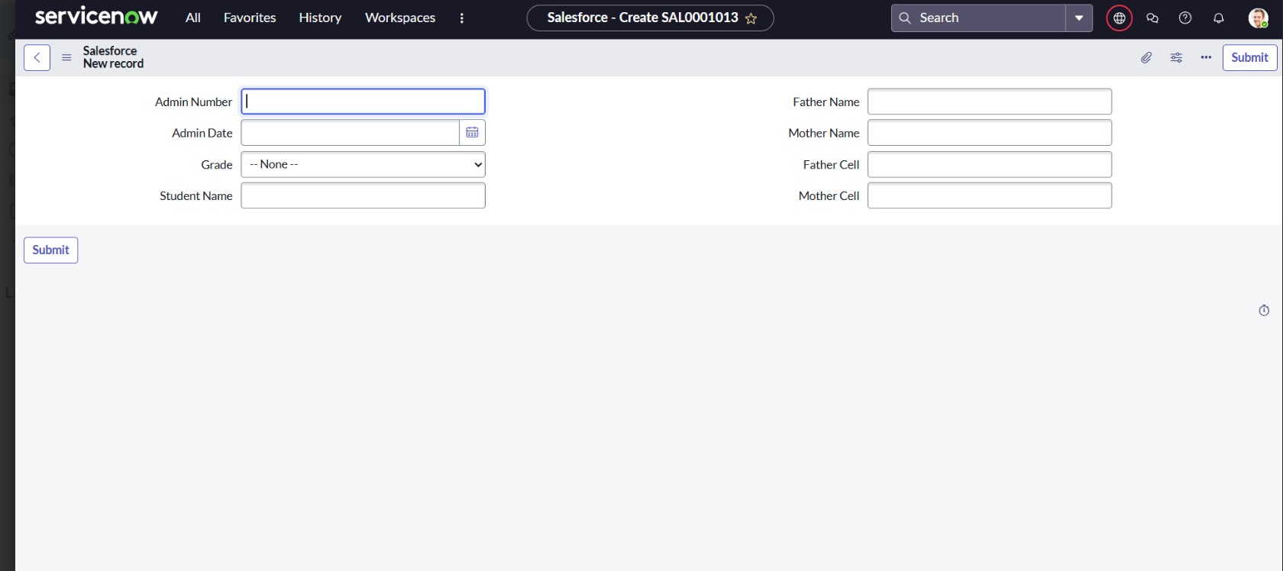

## Known Issues

* Form layout may vary slightly on different devices.
* Client Scripts dependent on exact field naming — ensure accuracy.

## Future Enhancements

* Add role-based user dashboards
* Integrate notifications (email/SMS) for admission status
* Extend to manage teacher data and fee structure
* Add reporting dashboards using ServiceNow Performance Analytics